**E2E process for Service Procurement**

**Service Procurement -** It refers to the process of obtaining services from external suppliers. Unlike tangible goods, services are intangible and often require a different approach to procurement. Examples include maintenance services, consulting, legal services, and IT support.

**Create Purchase Order:**

1. Create Purchase order with or without reference to purchase requisition through SAP standard Transaction code: ME21N
2. Pass the item category D in PO line item to denote service order and cost object K – Cost center
3. Pass the value of Cost center in which cost of service will be charged
4. Enter data for Service Code, Quantity required , due date of delivery, plant for which services are to be rendered, supplier code , item tax rate and price at PO line item
5. Save the purchase order and system would generate a new number based on the number range assigned to PO document type in configuration

Purchase order number is generated and same needs to be released at next step.

**Release of Purchase Order**

1. System determines the release strategy based on the release strategy configuration
2. It also reads the master data maintained against class/ characteristics maintained in the system for release parameters
3. There are two ways to approve the purchase order
   1. Option1 : to approve the Purchase order through Transaction code: ME29N
   2. Option2: Setup workflow configuration, system will trigger work item in the inbox of approver
   3. Approver will use the Tcode: SBWP to approve purchase order
4. Post document approver further steps of good receipt can be executed
5. Save the approver action

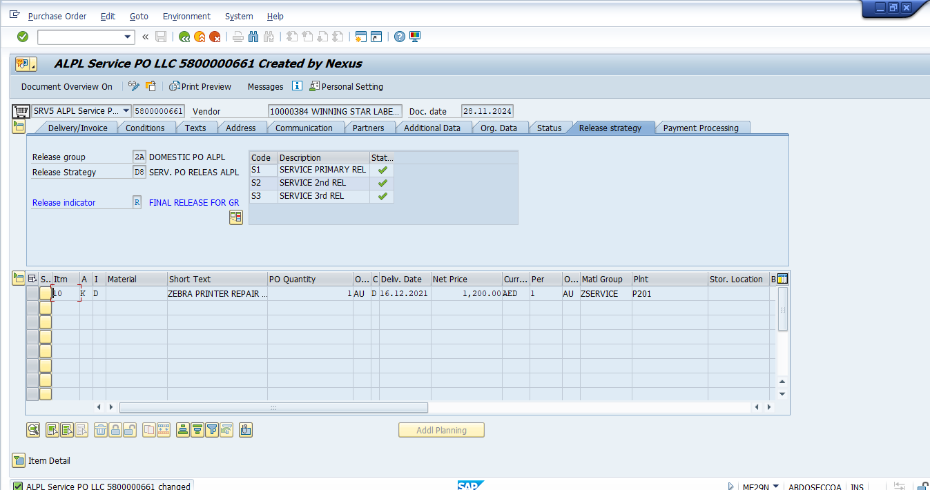

**Create Service entry sheet with reference to Purchase Order**

1. Service entry sheet is used to record , service received by the organization
2. This can be done by using SAP transaction code: ML81N
3. Enter the service PO number and line-item no
4. System will default all the services with pending quantity from PO for which service entries are required to be received
5. User can amend the quantity of services received
6. Post saving system will generate a service entry number
7. Post release, system will generate a good receipt document and accounting document to show its impact on financial books

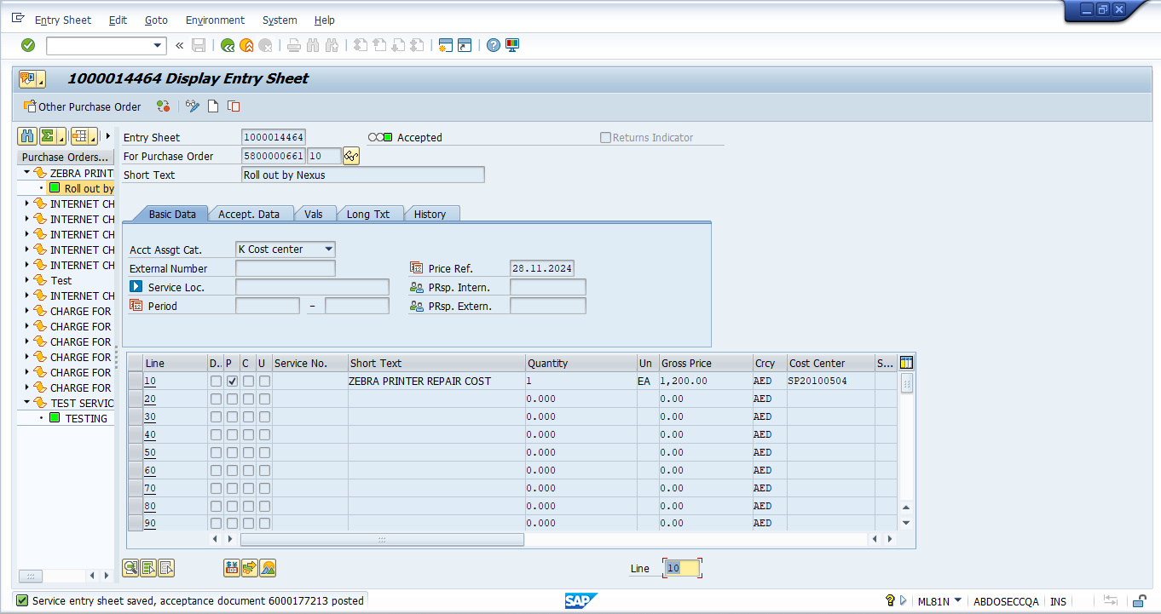

**Invoice Verification against Purchase Order**

1. Perform Invoice Verification by SAP standard Tcode: MIRO against Purchase Order
2. System will default all the open line items with open quantity and value for performing good receipt vendor invoicing
3. System will default the tax code from PO line item and calculate the taxes
4. System does 3- way matching among PO, Good Receipt and Invoicing to avoid any discrepancy
5. System also defaults currency and payment terms to calculate the due date when invoices can be paid

